PROGRAM:-
n = 4
dist = [[0,0,0,0,0],[0,0,10,15,20],[0,10,0,25,25],[0,15,25,0,30],[0,20,25,30,0]]
memo = [[-1]*(1<<(n+1))for i in range(n+1)]
def fun(i,mask):
if mask == ((1<<i)|3):
return dist[1][i]
if memo[i][mask]!=-1:
return memo[i][mask]
res = 10**9
for j in range(1,n+1):
if (mask & (1<<j))!=0 and j!=i and j!=1:
res=min(res,fun(j,mask &(~(1<<i)))+dist[j][i])
memo[i][mask]=res
return res
ans=10**9
for i in range(1,n+1):
ans= min(ans,fun(i,(1<<(n+1))-1)+dist[i][1])
print("the cost of most efficient tour = "+str(ans))

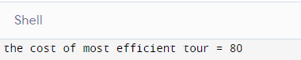
OUTPUT:

